Mary’s top tips for editing in Adobe Premiere

- This Handout is also on the weebly site and on Blackboard as a PDF.

- Red dots on the images are placed there to draw your attention to something key mentioned in the text. You can zoom into the images to see detail.

- This is a guide to your learning, not a recipe for a problem free submission. You will need to make a few mistakes, and go beyond this general guide to solve problems not identified here.

- The link below will take you to one of a series of intensive video tutorials on Lynda.com. This series is excellent, but focuses on live action editing, where content management can be massively intensive, with hours of footage and audio clips. I would advise that you work through the tutorials after the deadline in preparation for level 2.

http://www.lynda.com/Premiere-Pro-tutorials/Performing-basic-audio-adjustments/371692/413956-4.html?autoplay=true

Top Tip - Before you begin prepare your workflow - Make sure that you place all your assets (audio files, moving image etc.) in a master folder with your name on it on the desktop of the computer you are working on and make a new folder in it called something appropriate like “Master Edit” and put your name on it.

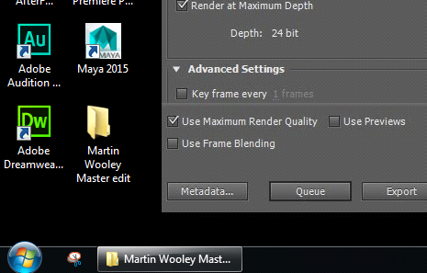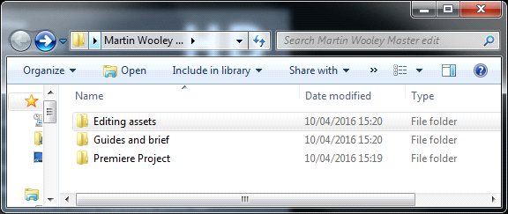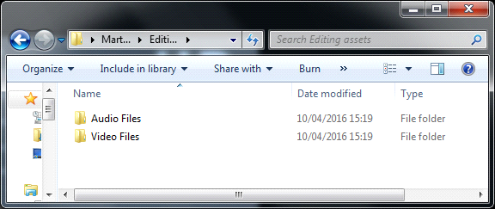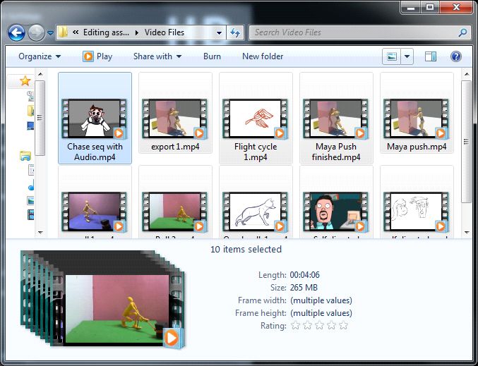

- Name the project something sensible.

- Use your browser window to put the project on the DESKTOP OF THE MACHINE YOU ARE WORKING ON in its nice new folder, alongside all of your clips.

Set these folders up before you begin the project, and do not rename or move anything once you begin. If you need to move to another machine then you simply save the master folder to the NAS drive, and copy it to the desktop of the new machine. All files and project info will move with it, and you wont have to find or relink footage.

File - New - Project or Sequence (see below settings)

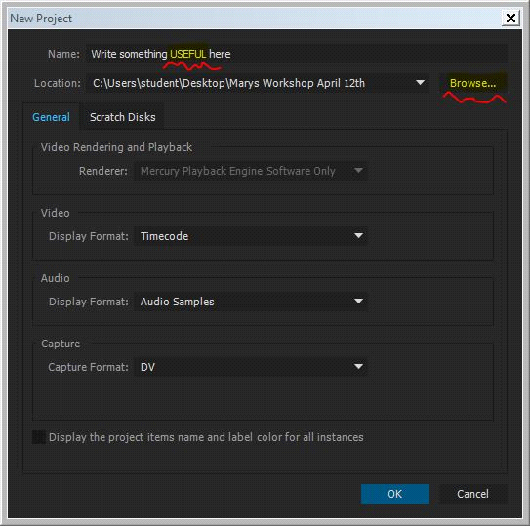 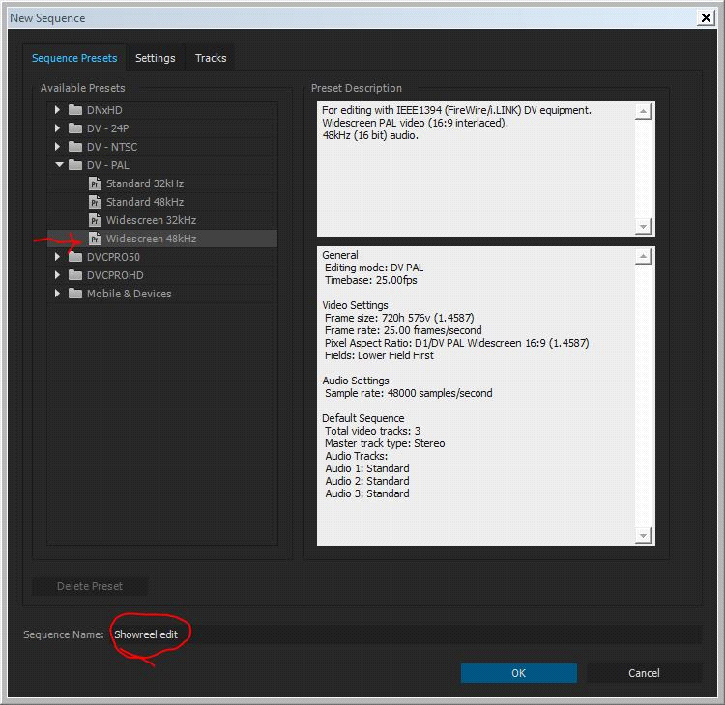￼

￼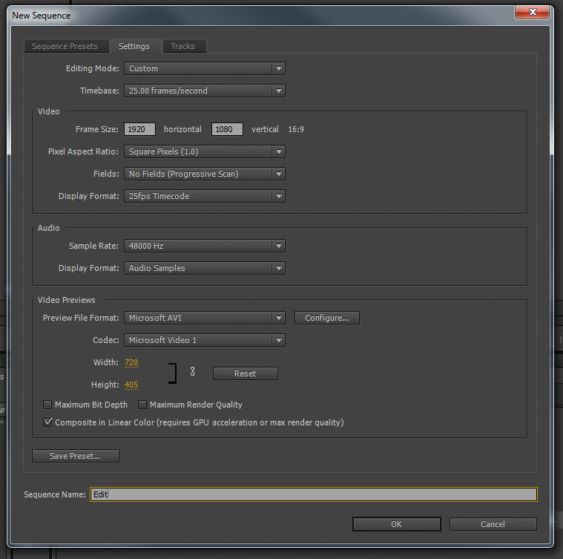

- When you are editing a film you will have worked out your workflow and pipeline before the editing stage, but as this is a show reel of different clips made in different processes select widescreen 48 DV pal as a pretty safe bet, but run a pipeline test to ensure no nasty surprises or loss of resolution.

- You also get the chance to name the sequence at the bottom of the page, this is useful if you are going to be working on more than one timeline within the project.

- I normally name my main sequence “edit” and then name any subsequent ones as I create them.

Top tip – As your files are likely to be slightly different, it is a good idea to re-export each one from the same timeline using the same settings as your final editing project. You can use this as an opportunity to “top and tail” or correct any issues, and rename them in the context of your show reel plan.

- Premiere has an AUTOSAVE - Edit - Preferences - Auto Save = adjust this to your requirements. Will save in same location you've saved your project.

- Premiere has lots of workspace options. You will want to work in the “Editing” window.

- Go to “Window” “Workspace” and “Editing” to set up your interface.

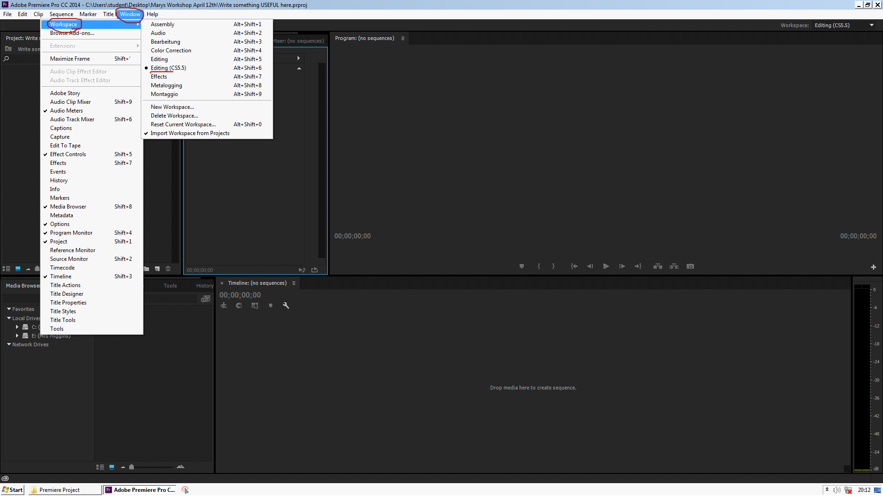

Top Tip - All the windows can be dragged around, so you can arrange size, placement and proximity to compliment the task at hand. When you move on to another task, you can easily re-order the windows to suit. If you get confused you can reset the original workspace in the same menu tab above.

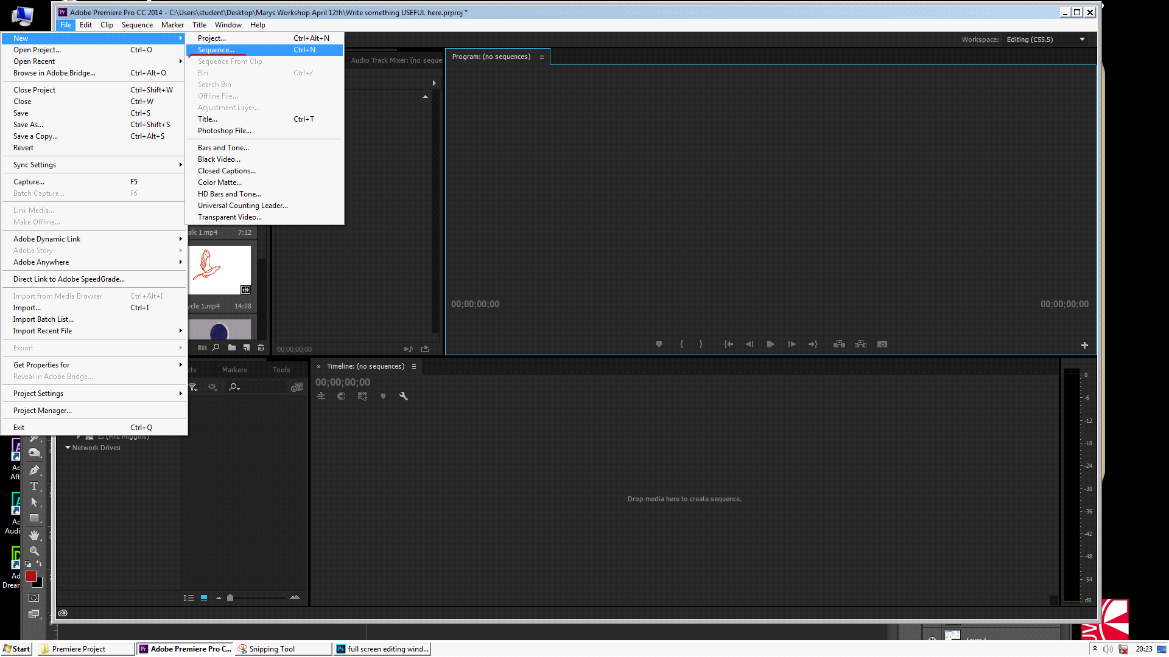

I always like to set up a “trim” or prep sequence. This allows me to prepare or modify any individual clips in the same project without messing up my main “edit” timeline. Lets say that your stop motion pull has some frames in the middle that you want to trim out. This sequence allows you to do that quickly. To set it up go to “File” “New” and “Sequence” and give it a name. It will appear as a second tab behind your main editing timeline.

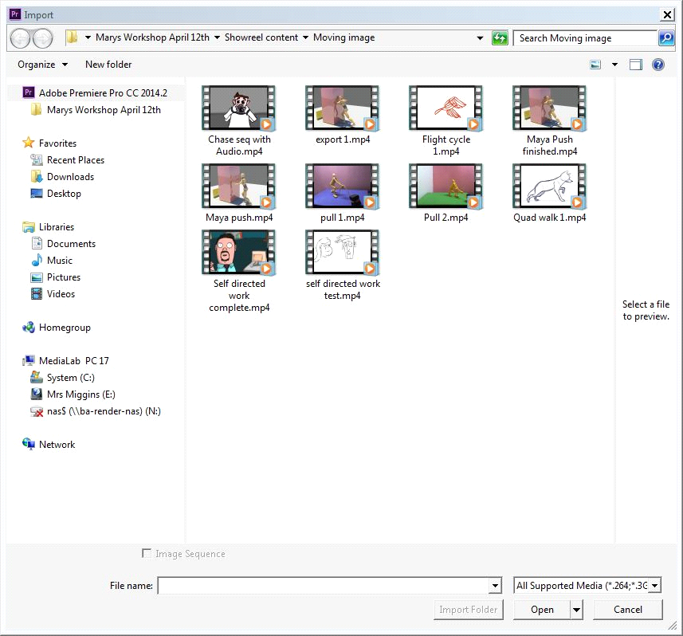

To import your work, go to “File” and “Import” and use your browser to get to the nice asset folder that you set up on the desktop. “Control A” will select everything and bring it all in at the same time.

Top Tip - Notice how easy it is to identify everything? That is because I trimmed these beforehand and re exported them so that there is no black at the start and end (this is referred to as “Topped and tailed”) it is much easier to put this in in Premiere if needed. They have also been renamed to make my editing easier.

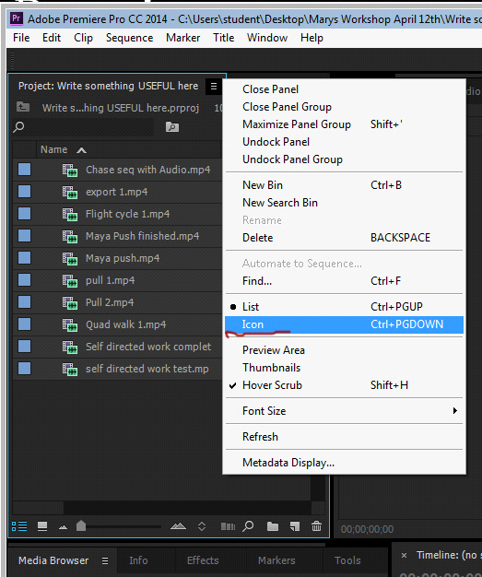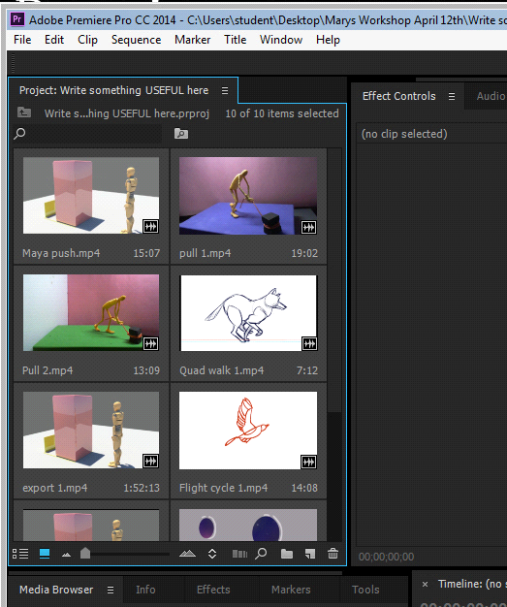

Before you begin you should always add a black video clip to your bin. This is a still image which can be reused over and over to place black on the timeline at the start, between clips, or to provide a background for titles. To get your black clip, go to “File” “New” and “Black video”.

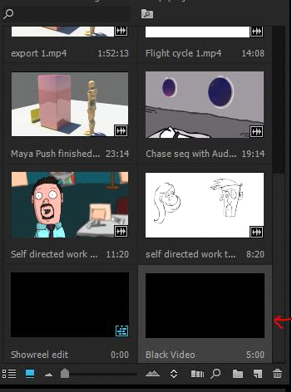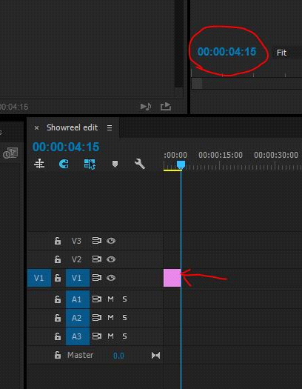

Click and drag your black video on to the timeline and push to the very left of the V1 (video 1) track. Place the “playhead” (Blue marker that scrolls through your videos) at the end of the clip. Your “Timecode” readout (circled in red above) will tell you how many seconds of black video you have.

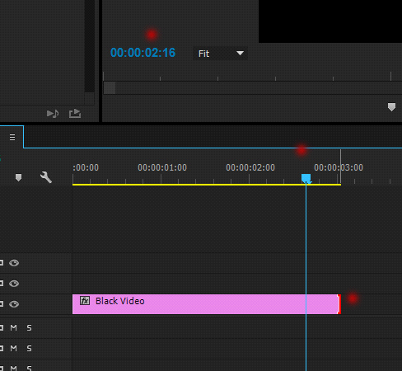

To adjust the clip duration hover with your mouse at the very end of the clip. You will see a red bracket with an arrow appear. If you click and drag here you will be able to adjust your clip duration. Or right click over the black frame - Speed/Duration and adjust your durantion. Here, I am setting it to three seconds which I think is a good start to a show reel. The red dots above all indicate the clip duration.

However, you can also zoom in and out of the timeline without affecting the duration of the clip. This is really helpful as you start to edit, as sometimes you want to get really close up to the footage, and at other times you need to see a much wider overview of the project.
The red dots at the very bottom of both images are placed on two small squares or “grab handles”. Clicking and dragging on these will adjust your view of the project, but will not alter the duration of the clips on the timeline.

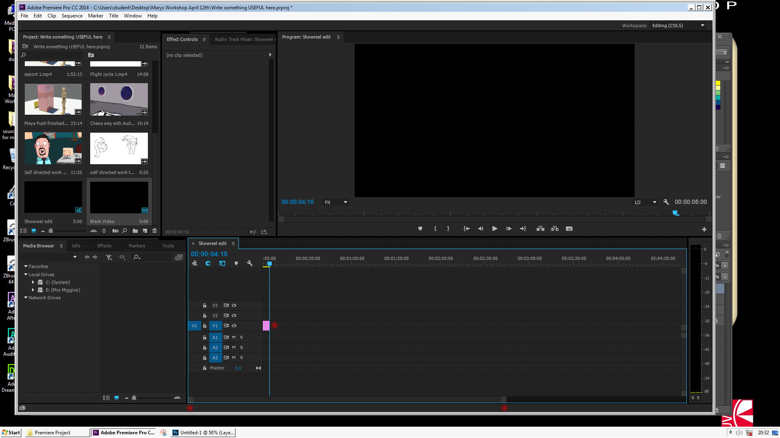

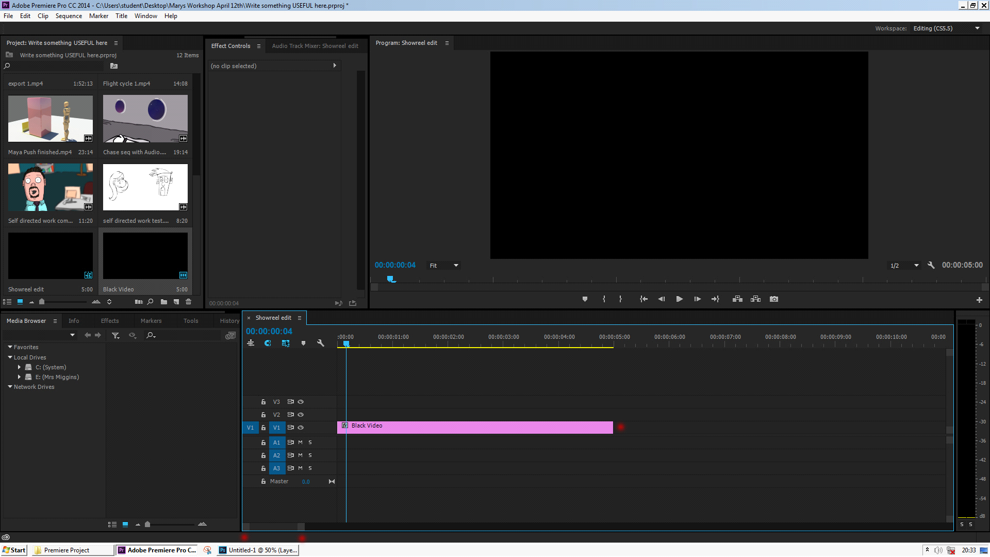

Top Tip – Have you ever bought in black video only to find that it is a tiny sliver on the timeline? This is because another user has set the “still image default duration” to 2 frames in order to sequence images in twos from Photoshop or illustrator. This can be easily changed to 3 or 5 seconds in “preferences” at the start of the project.

Next we will need a main title. Go to file, new and title and this window will appear. The settings will be informed by your project, so you don’t need to do anything here other than name this title. If you don’t the software will name your titles 01, 02 etc. which gets very confusing if you swap clips around later in the process. I recommend using the exact text that you intend to use in the title, as this allows you to easily identify it.

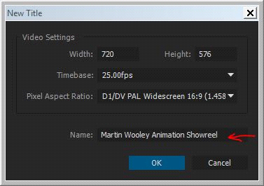

The title interface can look confusing at first, but you will only need to use about 5 tools here to make clear titles for your clips. The red dots indicate these key tools.

- The “T” at the top left is your text tool. You will not be able to write anything until you have clicked this and then clicked in your main title window. (to the right and slightly lower down)
- Once here, you should see the curser pulse, and you can go over to the “Font Family” and “Style” selector. Use a clear simple font. You can resize the font here after it has been written.
- Further down on the right you will see the colour picker. Double click on this window to select your colour. Here, as my play head is on a black clip, my text will need to be in high contrast. Further down the line, your text may be over an image, and you will need to select a colour that shows well.

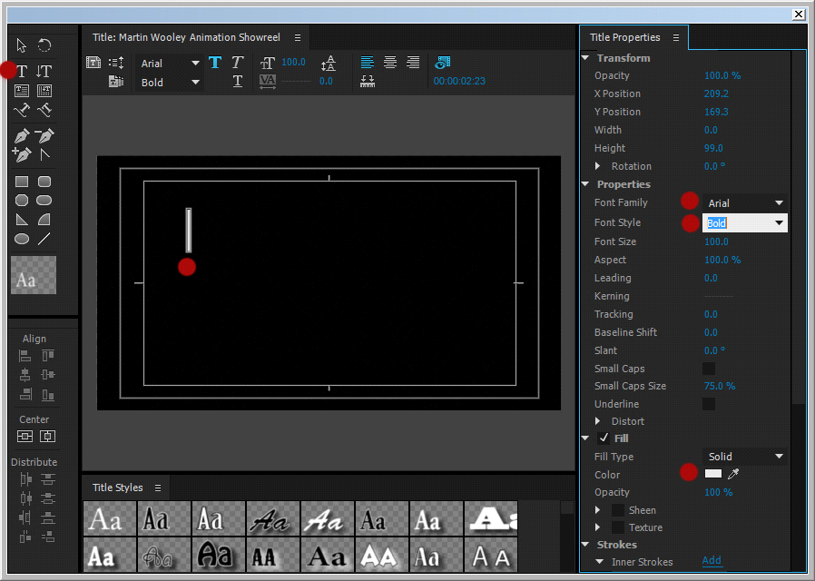

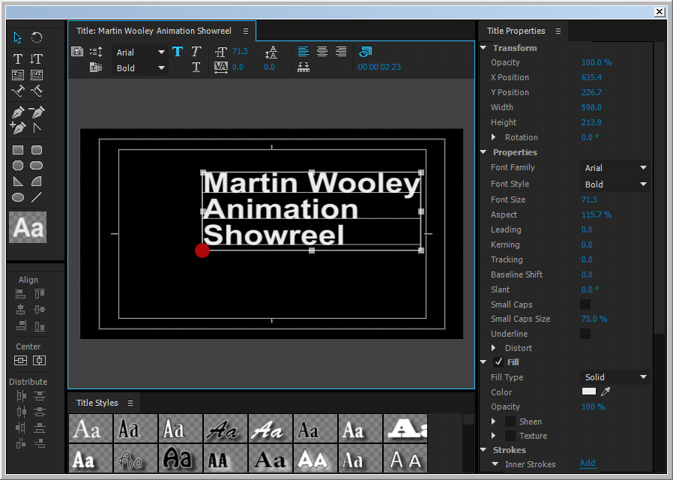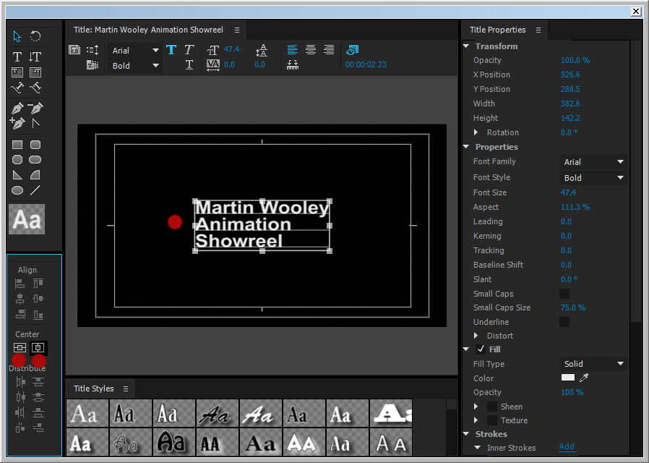

Select the arrow tool (Just above the “T” tool and click and drag the text to position it. Click and drag the corners of the text box to resize

Top tip – If you hold down the “Shift” key as you do this the text will remain constrained, and wont squash or stretch as you do this. Also, the two red dots in the left hand side of the right image show two very hand little tools which will center the text perfectly once you are happy with the size, colour and font.

Shut the window and the title will appear in your bin alongside your other clips.

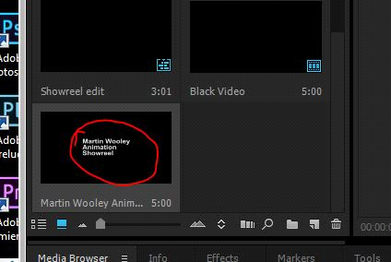

Click and drag your title over to the timeline and place it on video track 2, directly over your black video.

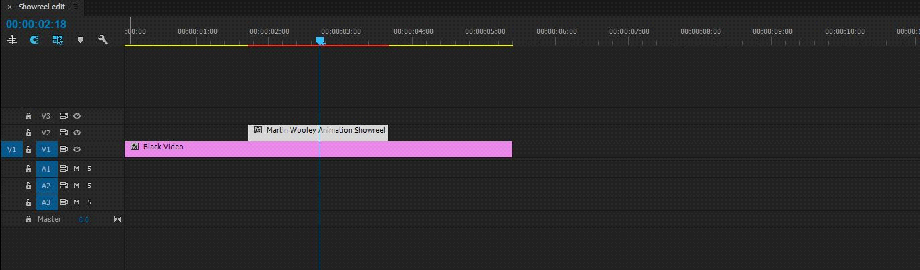

If you move the playhead over the clip your monitor will show your title for the duration that the clip has been set. As the title is also a still frame you can make it any duration you like.

Top tip – It is important to know that when you make a title the background is always an alpha channel, meaning that it is transparent. The black you can see here is the black clip you have placed below. If you want the title to appear over an image or a clip, place it over the selected position on the timeline and the text will appear as part of your clip.

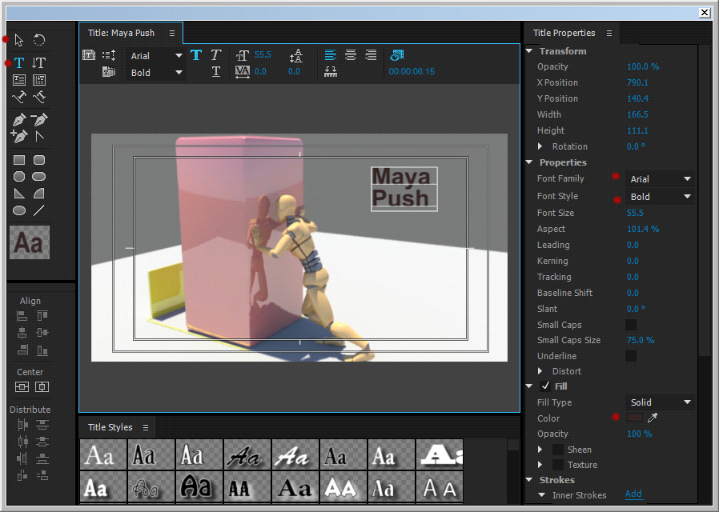

The duration of your clip and title are very much a matter of personal choice, but there are some ground rules, If the title appears on the first frame this can seem abrupt for the audience, and dosent give you much time to settle after clicking “play”. If there is too much black it looks unprofessional and the sequence gets off to a slow start.

Top tip – one thing which can really help to get your reel off is music. We will be talking about audio later on in the guide, but it is a good idea to place your music track on the audio timeline as soon as you begin, and time your opening titles to the beat, (leaving three seconds of silent black video)

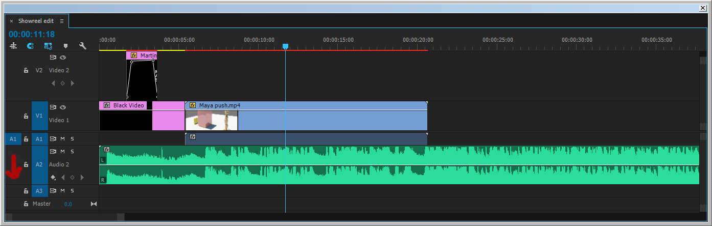

Top tip – Titling, black video and cross fades are all tools that can be used by the director to communicate to an audience. How and when they are used are pretty much a matter of choice, however, here are two vital bits of information in the context of your level 1 semester 2 hand in

If I want to make the text fade in and out, I need to adjust the opacity of the clip over time. This means that I will need to set key frames. There is an entire window called “Effect Controls” which allows me to set keys and make fine adjustments to my footage, but there is an alternative and very easy and intuitive to set “opacity ramps” (cross fades) which is very similar to the way we can adjust and mix audio levels, and well worth learning.

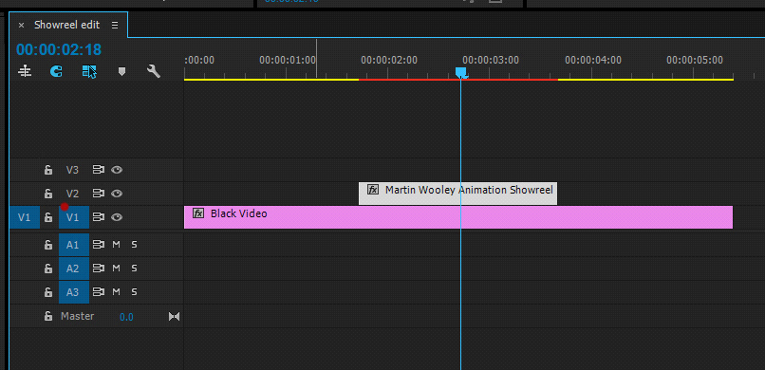

Your timeline will look like this, but you can expand it to reveal a simple way of adding key frames and creating opacity ramps. Firstly, hover with your mouse over the top of the blue V1 square to the left of the clips. (Indicated by the red dot) You will be able to click and drag the window upwards to expand the height of the track.

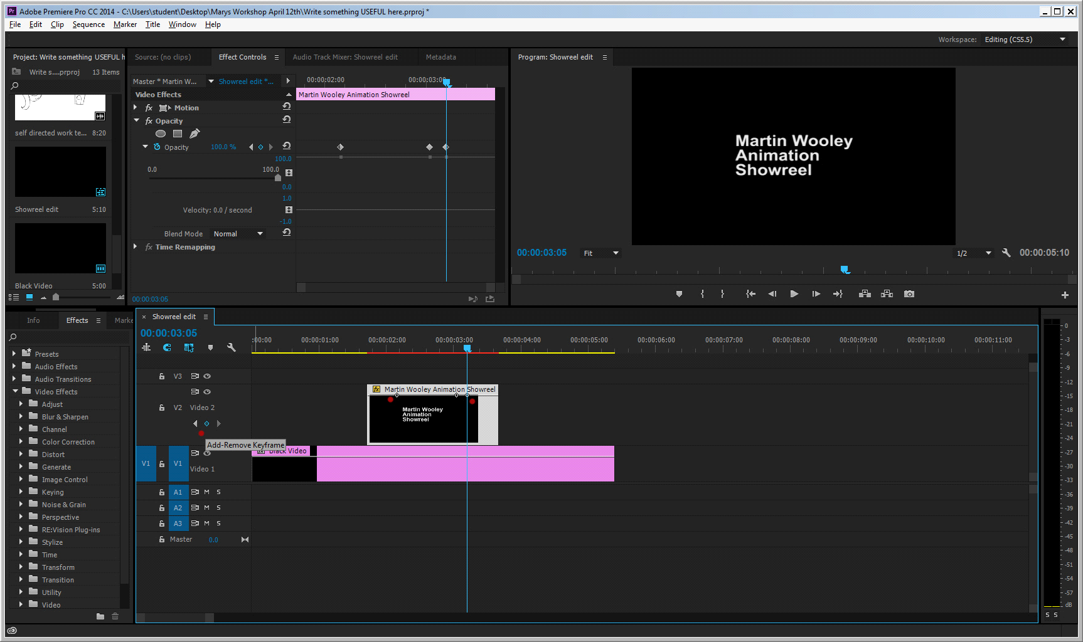

If you look at the clip (with the two red dots) you will see a thin line near the top. This indicates the current opacity level, with the clip totally opaque (meaning you cant see through it)
The first red dot on the left indicates a blue diamond which will add a key frame on to the clip if…..If you can't see this right click over the footage and Show Clip Keyframes (at the bottom) Select Opacity.

- The clip is selected
- The play head is on the clip.

If you click on this diamond when both of these steps have been taken a little dot will appear on your clip along the opacity line. You will need to create four of these to allow the title to both “Fade in” and “Fade out”. Don’t worry about where these are positioned, as you can easily click and drag them into position.

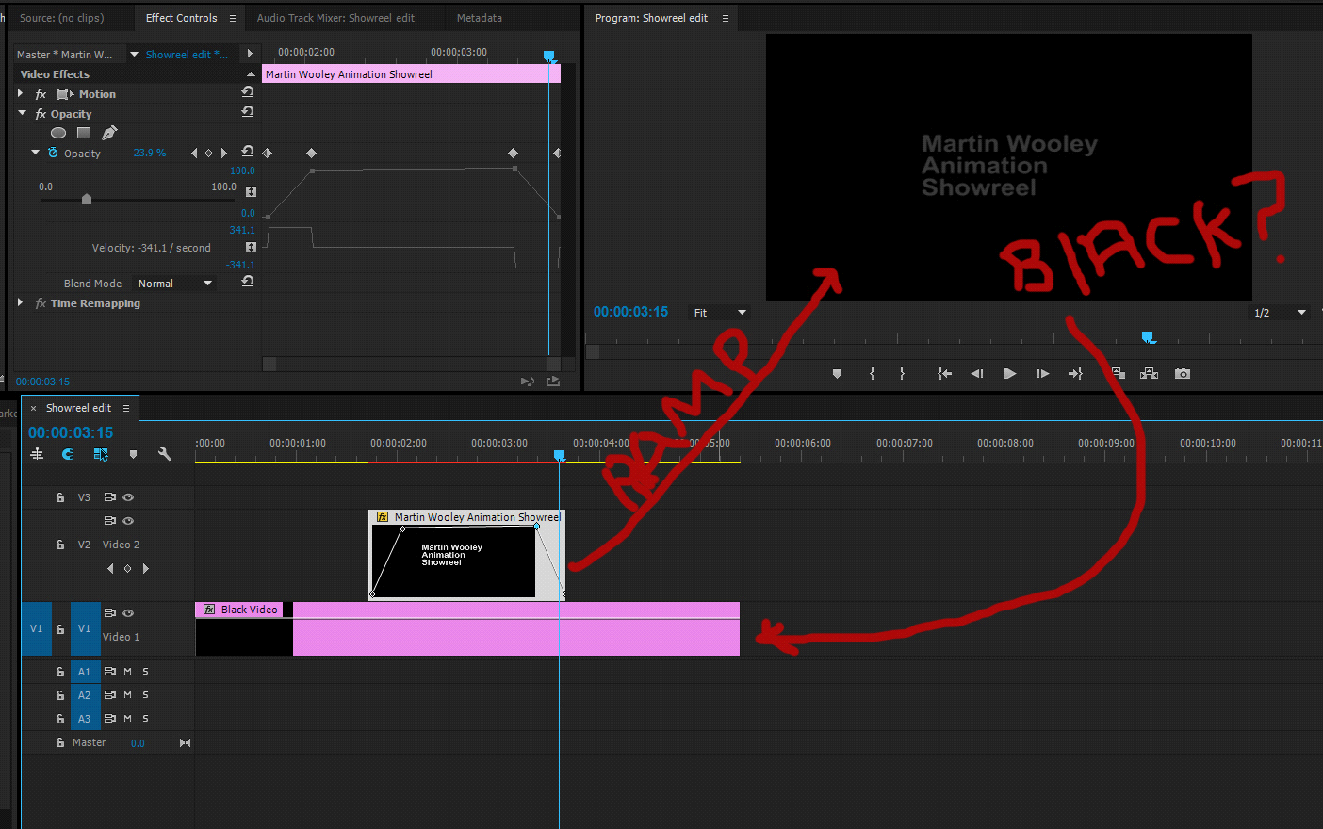

If you click and drag the outer two dots or “handles” to the bottom of the clip icon you will be telling the computer that when the play head passes over here the clip is completely transparent.

If you leave the inner “handles” at the highest position you are telling the computer that when the play head passes over these sections the clip is totally opaque. The ramps between represent your fade in and out, where the text is becoming opaque (ramp sloping up) or transparent (ramp sloping down)

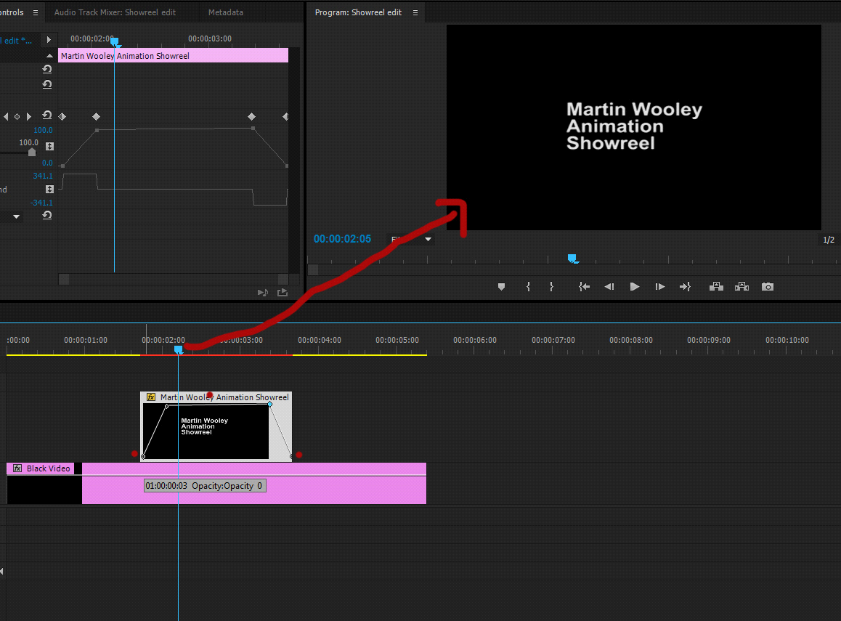

This process takes a few practice runs to get right, but once you do it becomes very intuitive and “tweakable” as you work. The audio volume levels are managed in exactly the same way.

You are now ready to begin to click and drag your individual clips in. There is no specific running order, so you can put them in any order you like. A good tip though is to start with a couple of clips that have no internal audio. This means you can let your chosen music track get going and carry the sequence a bit before you have to drop the volume. Also, there is no rule about how you manage the titles. They can be very formally placed over black video, or dropped on to the actual clip as long as they don’t obscure the action.

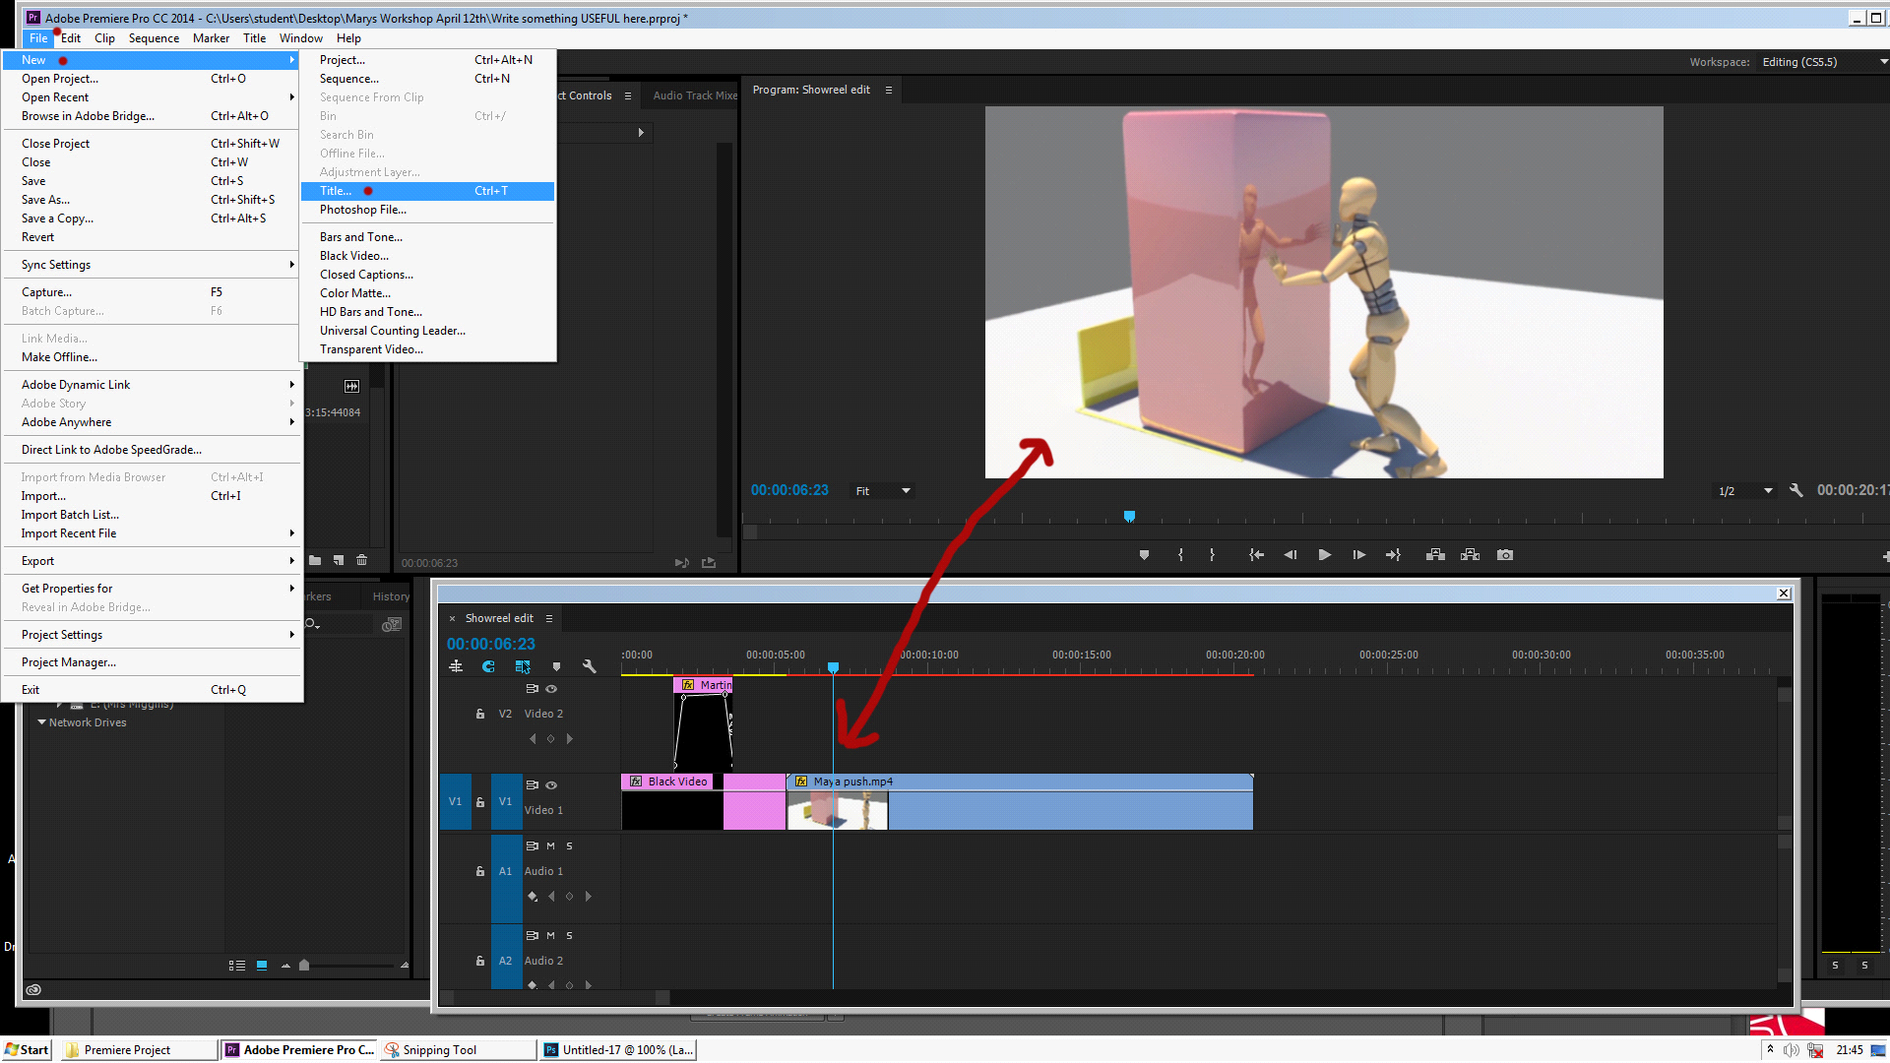

Unlinking Audio
When you bring in a silent track, Premiere will “allocate” an audio clip which will appear in the audio timeline directly below your clip. This is unnecessary if there is no audio in that track coming in to the project, so you can delete it by right clicking with the mouse on the audio and selecting “unlink” to disconnect it from the video. Then you can deselect both clips, and reselect the audio and hit delete. Obviously, you don’t want to do this if there is connected audio on the clip.

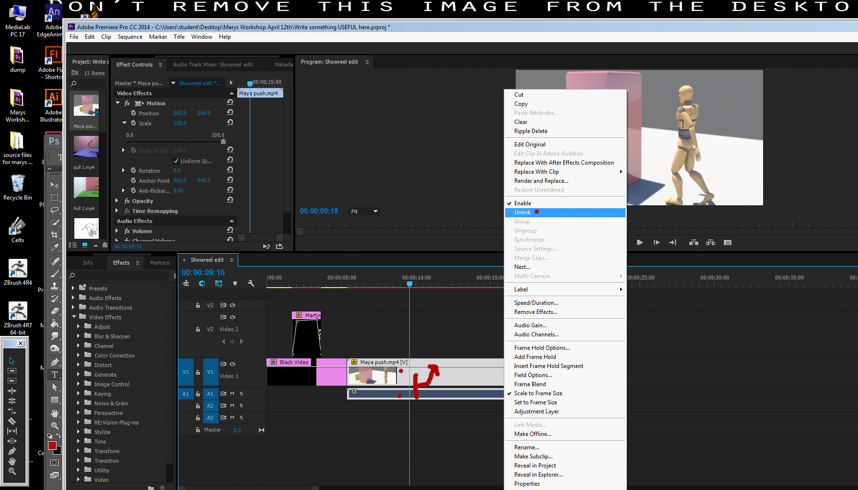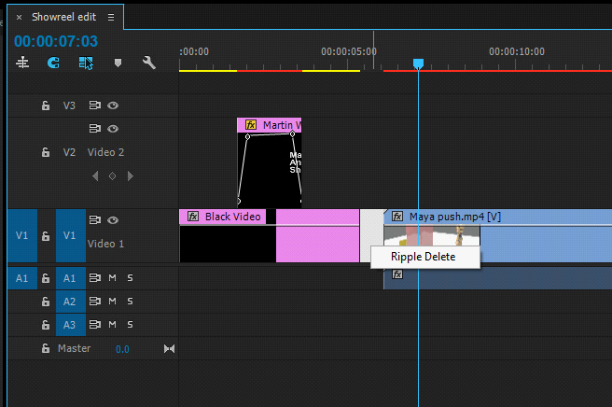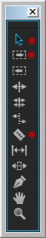

Ripple Delete.

This little function is a lifesaver when you begin to build up lots of clips, and you are moving around within the edit making small adjustments. If you have a gap in your track that you want to close simply right click in the gap and the words “Ripple Delete” will appear. When you click on them the gap will close, but with EVERYTHING on that track moving also. This helps to prevent your edit getting messed up every time you trim a bit of black video or a title. The “Move Track” tool is also a lifesaver when making space on a complex edit.

Clip Size

Sometimes when you bring a clip down to the timeline it appears too big for the monitor window, and the edges have been cut off. If this happens, select the clip, and click on “scale to frame size”. The clip should jump to the right size.

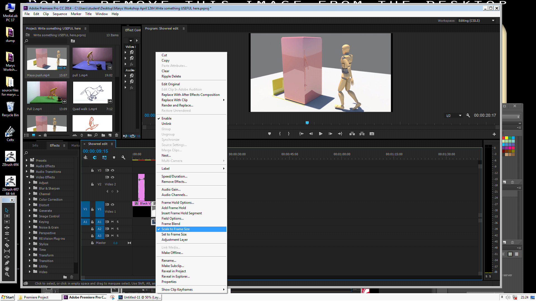

Clip shape - Correcting inconsistent aspect ratio.

Your project will adapt to the best aspect ratio for your clips, but as these are from a range of sources, and you have not necessarily been in full control of your workflow the aspect ratio will be inconsistent. This will result in some clips having a small black band down the sides. The image can be resized and reframed in the “effects controls” window by setting key frames and selecting and adjusting “scale”.

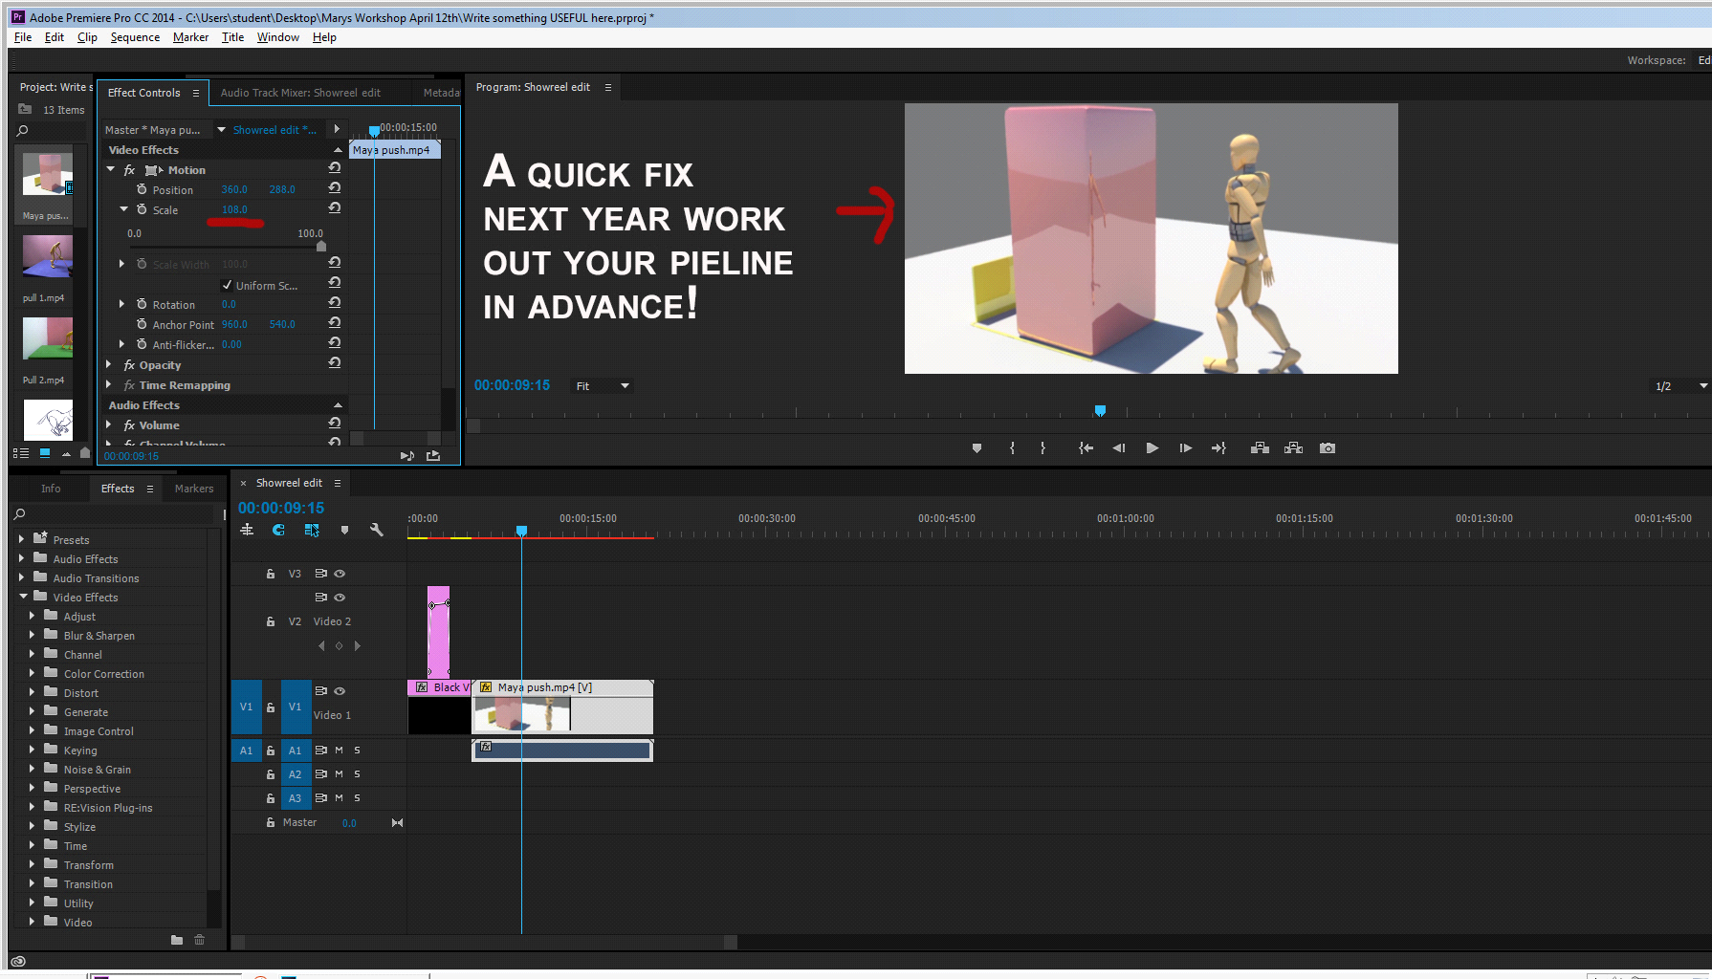

Managing a complex timeline
As your sequence grows, the timeline can get very complex, with multiple layers of audio and video. If you are getting a bit overwhelmed you can create a new sequence within the project which will give you a blank timeline to build titles, crossfades etc., and then import them into your main sequence.

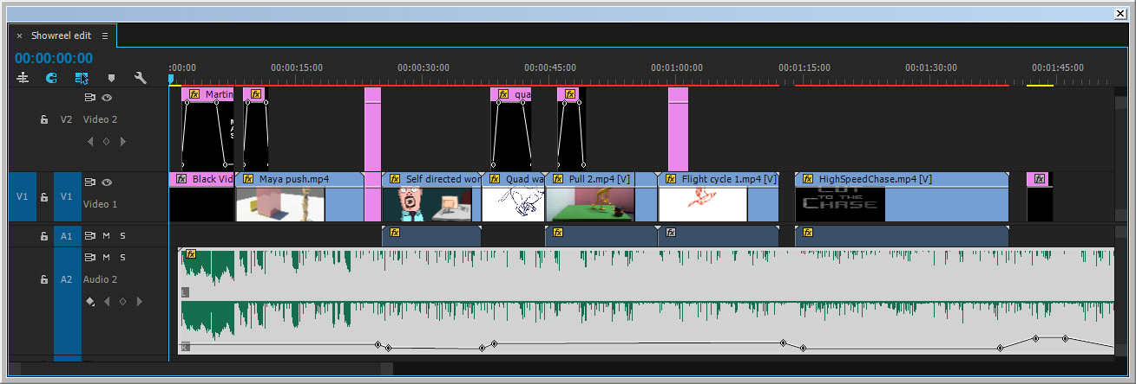

Working with Audio

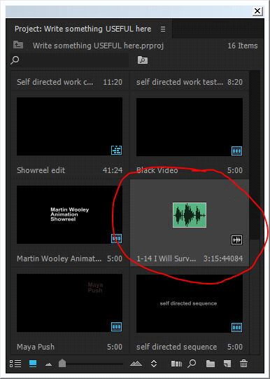

Make sure that the audio goes into the correct desktop folder before you import it. It is all too easy to pull audio in from a pen drive or the NAS, and then to lose it if the project moves.

Start with your music track early in your edit session. Pull it in and set it on Audio 2 to start three or four second’s in.
(Audio 1 can then be used for “internal” audio already attached to specific clips.)

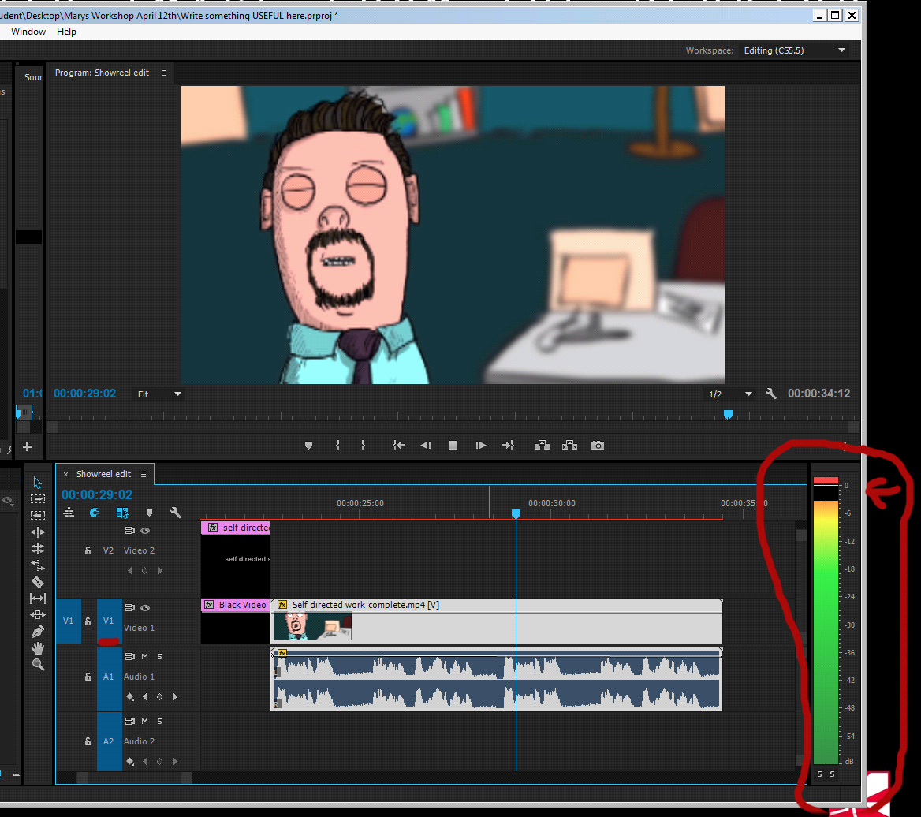

Expand the track to reveal the key frames as you did with the video track earlier. You should be able to see the waveforms clearly. Play a section and keep an eye on the two audio indicators on the right hand side of the window. These indicate your audio levels, which should be peaking between -6 and -12. If they go any higher the two boxes at the top will appear red. A high peaking level will be extremely loud, and possibly distort the speakers on playback.

The white line running down the middle of the clip (between the left and right waveforms) is the volume. Simply click and drag this down to lower the volume. Ideally the loudest noises should be between -6 and -12 and the red boxes at the top should not light up. You can do the same thing if the audio is too quiet generally and needs a boost.

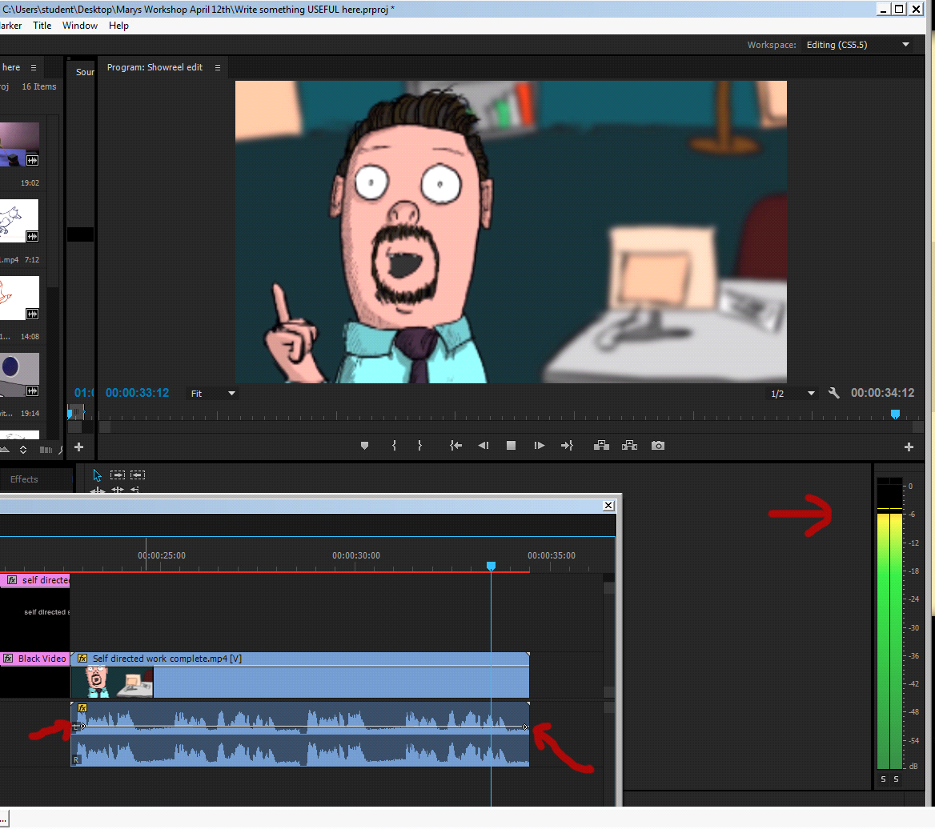

When you bring in a clip that has its own audio you will need to adjust the volume just for the duration of that clip.

If you look at the music track on Audio 2 you will see that I have used key frames to “Dip” the music down when a track has internal audio. For the first one, the audio is still a tiny bit audible, but for the chase sequence it is at the lowest level possible, meaning that it is completely silent. It did take a bit of jiggling around to get the ramps working well, but it is worth it if the audio plays well and complements the reel.

The last thing you should do on your edit is to “normailse” the audio. This will make sure that there are no audio peaks above -6.

Exporting your sequence

Make sure that you have checked your sequence through for any spelling mistakes, missing clips or funny blips. When you are ready, go to “File” “Export” and “Media” The Adobe Bridge window will pop up.

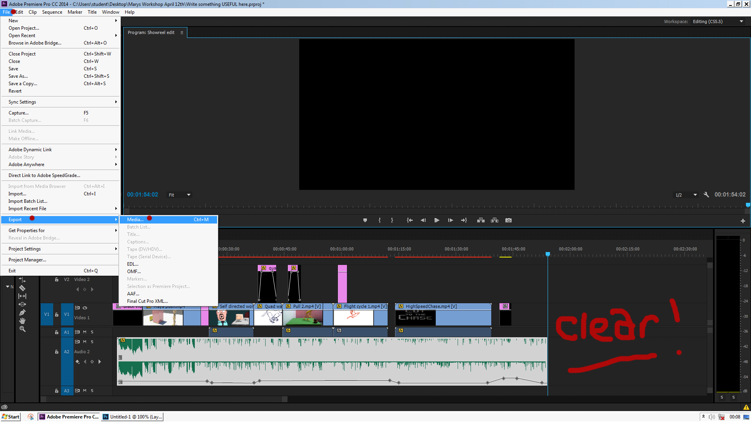

Top tip – make sure that there the timeline is clear from the final frame of your sequence. A random clip shoved down the timeline can add an hour or more to your export time. Also, make sure that your audio clip ends on a fadeout.

An example of a set of EXPORT SETTINGS FOR PREMIERE CS

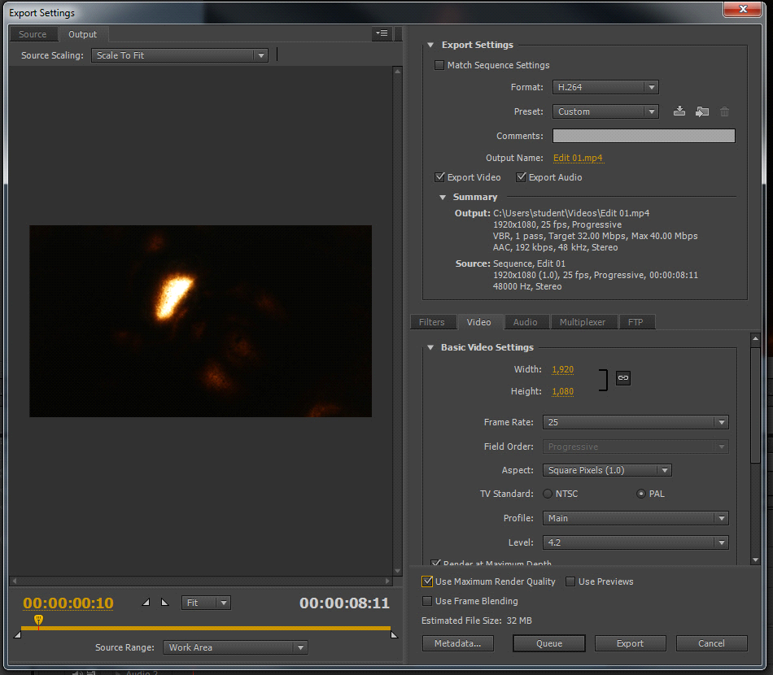

EXPORT SETTINGS FOR PREMIERE CC 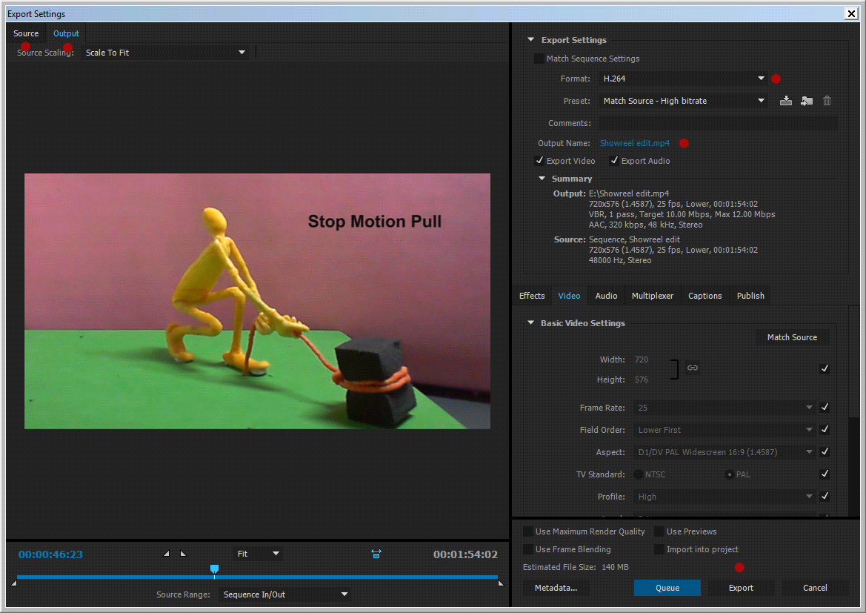

At the top to the left you will see two tabs labeled “Source” and “Output”
Will indicate any inconsistencies between your sequence and the final export. You will also see a timeline at the bottom of the sequence window. Click through your sequence here, and toggle at key points between the source and output to check that there will be no nasty aspect ration surprises on export.

A rough guide to your settings
I would suggest that you select H264 as your format, and in Preset select “Match source, high bitrate” this should generate a high-resolution but digitally light file.

Youtube = Container = MP4, Codec = H.264
https://support.google.com/youtube/answer/1722171?hl=en-GB
Vimeo = Container MP4, Codec = H.264 https://vimeo.com/help/compression

Click on the text to the right of “output name” and browse to your destination folder. This could be the desktop, the NAS, or an external storage device, depending on your needs. Give the file a sensible name that will not confuse you later, and click “Export”

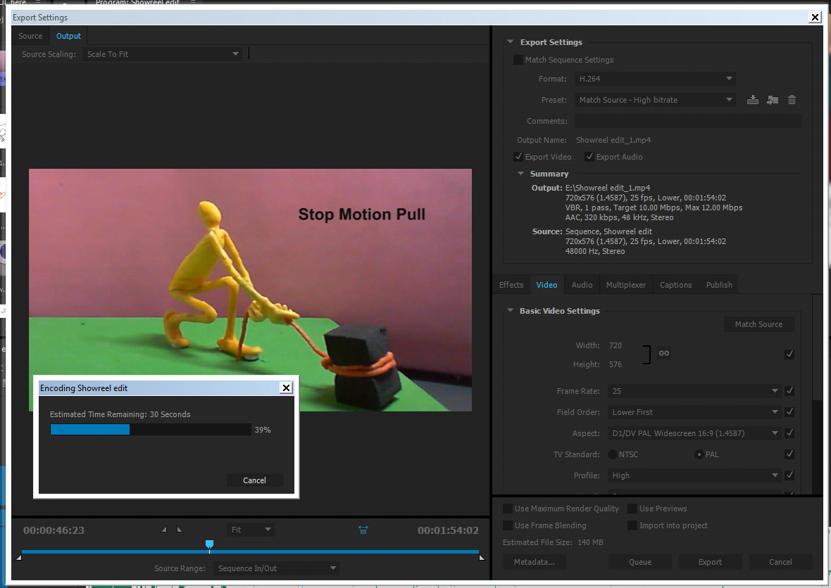

You will see an encoding window that will indicate the percentage of footage encoded. When this window has reached 100% your file has been exported and will appear in the destination folder.
Check it on a projector with speakers to make sure that it plays properly, and then copy the master folder to your own student folder on the NAS and delete the local version. Otherwise the machines will slow down.

