Design for animation
One day brief.
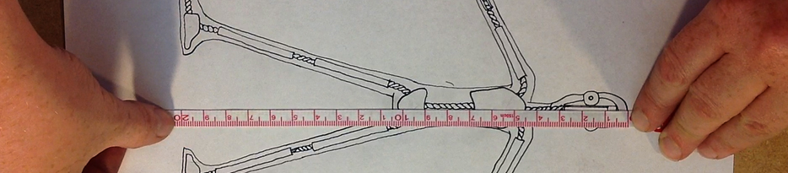
What are we being asked to do?
- You should already have a basic design concept for different character design challenge.
- You will have a lecture and demonstration on the key skills and areas of concern for the stop motion puppet designer/maker.
- You will then have until Friday to produce one of the most vital tools for the puppet designer
In stop motion, there are three key design tools for communicating design and fabrication details…
- Concept Art – Sketches/drawings that show the external shape of the character – details of its costume – facial features etc. You should already have this.
- A scale drawing – a more technical exploration of how you might approach incorporating an armature inside the puppet
- A mood board, showing key materials, textures and fabrication choices

Your final scale drawing can be presented on one well-presented illustrated document, showing key visual details and clearly annotated with correct technical terms and vocation language specific to the stop motion paradigm.
It is your job to demonstrate an understanding of the key technical challenges faced in puppet design as well as to show your skill in conceptual design. You will do this by clearly indicating the following in your scale drawing

- K and S technology in the head and hands
- An indication of how pin tie down technology will be incorporated into the foot
- A clear understanding of the rigid and flexible parts of the armature and how it fits into the body
- The importance of reducing weight where possible
- Some indication of colour and texture (swatches)
A comprehensive hand out and illustrative images have been places on both the NAS drive and the WEEBLEY website to help you out.
At any point up to 5pm on Thursday evening you can e-mail me a SMALL version of your work in progress, and I will e-mail you back with comments and suggestions for improvement.
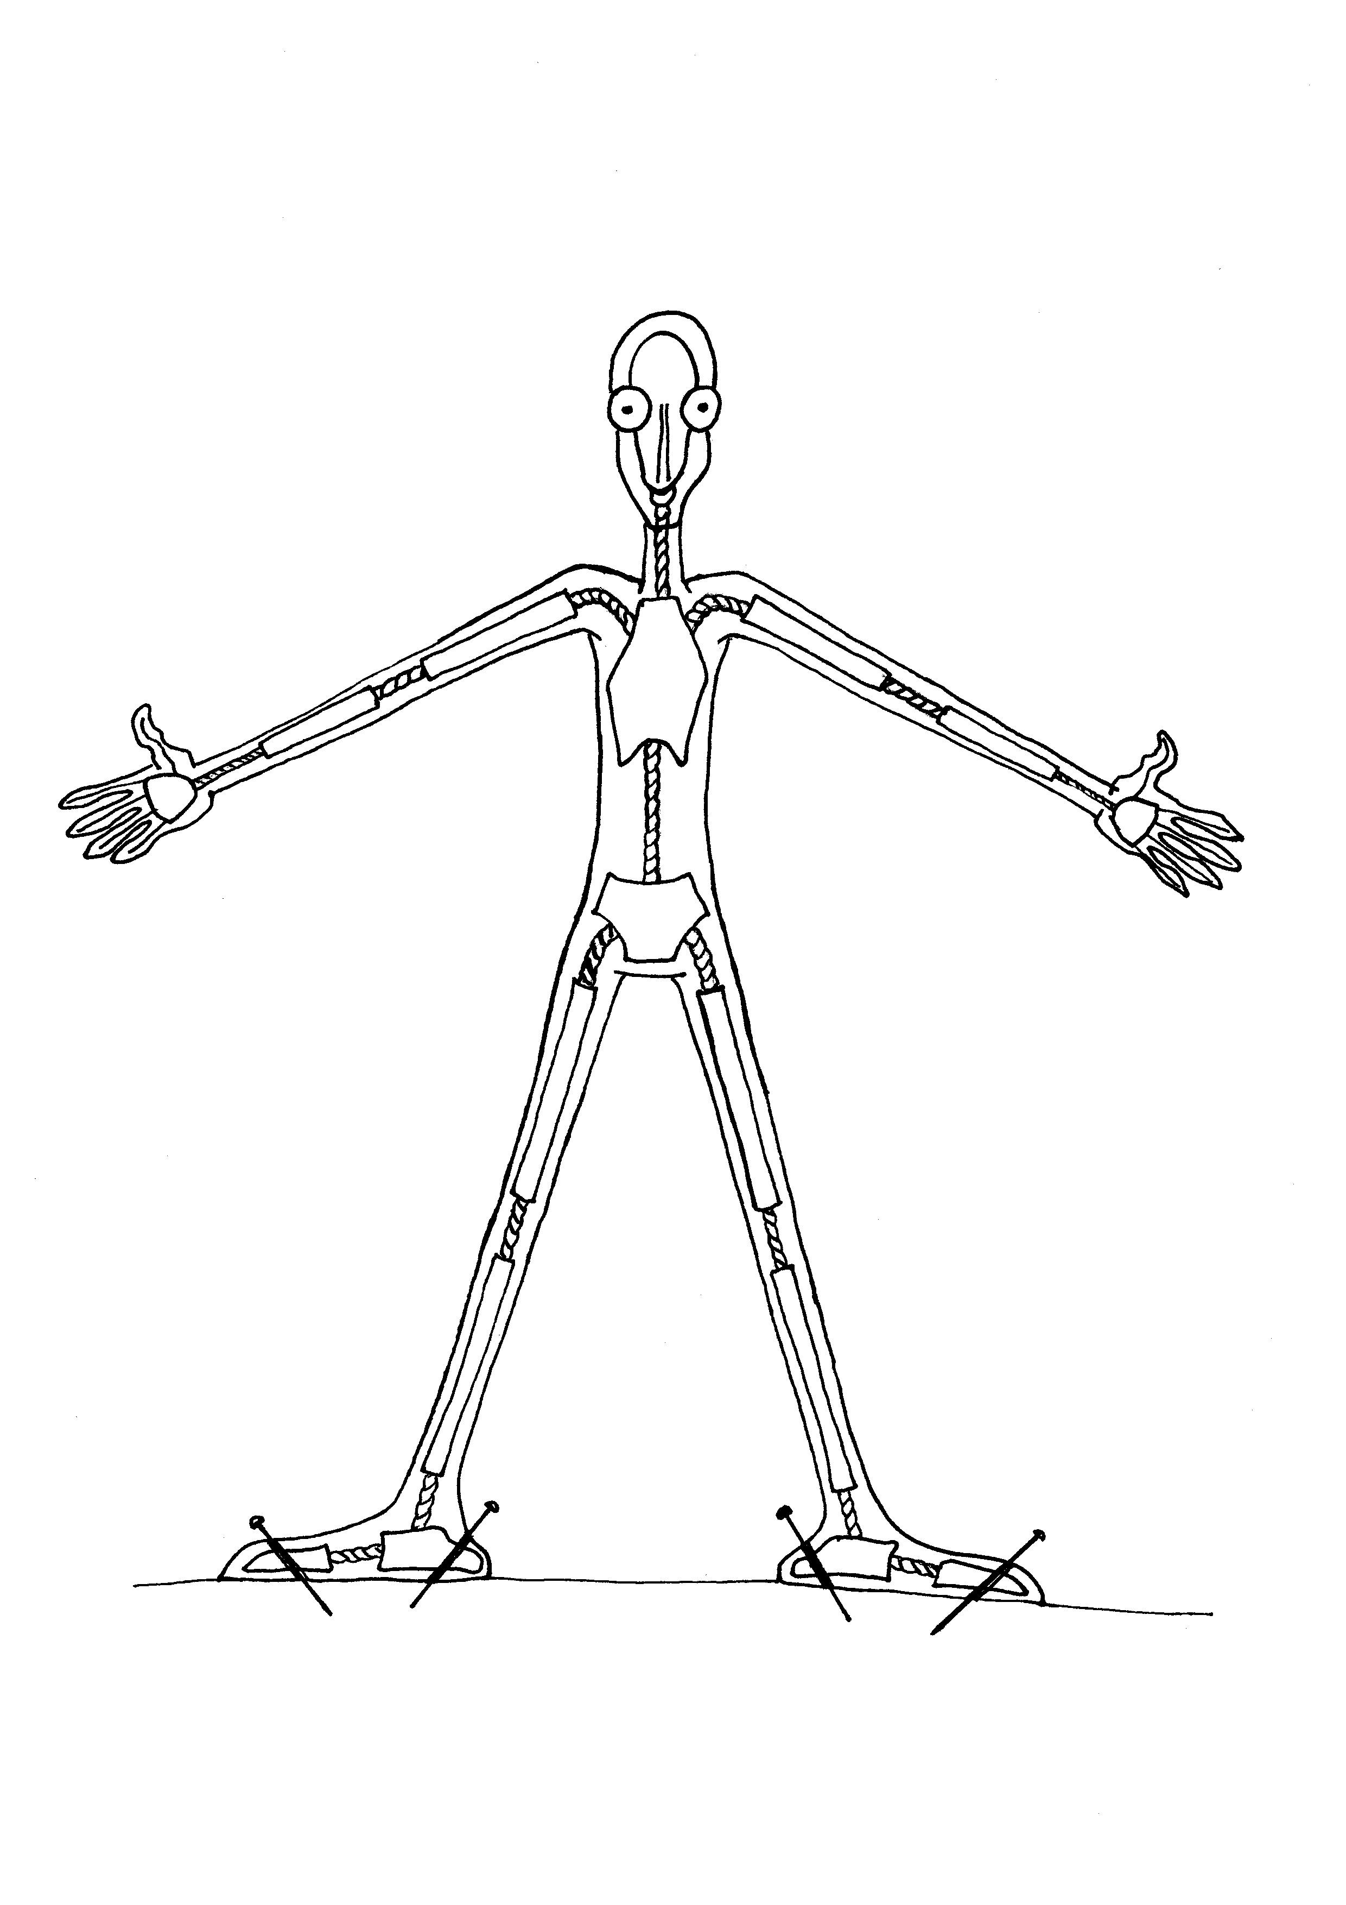

The drawing should be the size of the actual puppet – (5 inches)

It should be clear, and well annotated to show your understanding
You do not need to indicate the nature of the materials, terms like Wire, bones, lightweight material etc. will suffice.
It should be a digital document, made digitally or using traditional drawing tools, but the annotations should be done digitally.
You can incorporate a side view if you have time.

