Workshop – Introduction to Traditional 2D Technologies for Illustration students

Aims of the session

- To introduce students to key tools and equipment used in the traditional 2D studio. (Peg Bars, studio punches etc.)

- To highlight the importance of considering your aspect ratio or frame shape from the outset.

- To highlight the importance of using a standardised system for registering 2D drawings.

Linetesting

- It is a process used by the traditional animator to check and review his or her work when run at 25 frames per second.

- The animator begins to create movement over a series of separate pages, (or frames)

- When he or she feels the need to check the movement, (usually after about six frames or so) they move to a “line Tester”

- A line tester is simply a computer, camera and software package set up to record animation at 25 frames per second. We use “Dragonframe” in the illustration studios.

- The animator then records the animation under the camera, and plays it back, checking their timing, pacing and line quality.

- It is very common to have a few false starts when animating for the first time, (the animation can run too quickly or too slowly for example) An early line test is vital, as it will save you from producing 400 or 500 drawings (potentially hours of work) and then discovering a problem with your sequence.

- The line test can often be quite rough, with obvious construction lines evident and a looser style is perfectly acceptable. The animator can continue to “tweak” the line test once the sequence has been completed, by adding or removing frames, reworking the line or replacing sections with entirely new drawings.

- When he or she is happy with the sequence, the animator often addresses the sketchy quality of the drawings by undergoing a process called “Clean-up”. Here, the animator simply traces each drawing carefully on to a new sheet of paper, taking more care with the line quality. A more illustrative “materials led” style would not necessarily require a clean up phase.

- Once a sequence has been tested, it can be further worked on using inks or paint and shot again. A more “digitised” product can be achieved by scanning each frame into a software package such as After-effects or Toon boom, where it can be composited with other drawings, backgrounds etc.

A Basic Guide to producing Hand Drawn Animation.

2D animation can be made using a simple flick book.

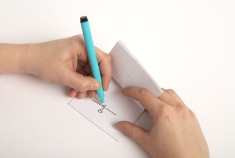

The images are bound together using a stapler or bulldog clip, and the animation is “played” by flicking through the drawings.

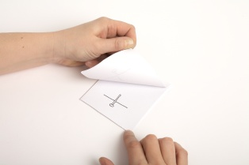

The size of the pages in the book provide a natural frame, within which your drawing can be positioned.

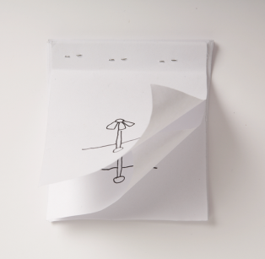

The staples hold the pages in place, and provide the “registration” which keeps the image from popping around the frame.

So even when making a simple flick book, we are addressing two key issues

Registration – both of the drawings as they are produced, and of the position of the image as it is captured by the computer.

The frame shape – in this case dictated by the shape of the paper, but when we come to “shoot” animation, we will find that it is the shape of the capture device (in this case a camera set to 16X9 settings)

In professional animation, two standardised tools are used in traditional hand drawn animation to address these two key considerations:

- Registration is addressed through the “Peg Bar” and through pre-punched paper. We will be taking a closer look at how the peg bar works in a moment.

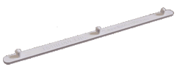

- Framing the image, and shooting that frame are addressed through use of an animation field guide.

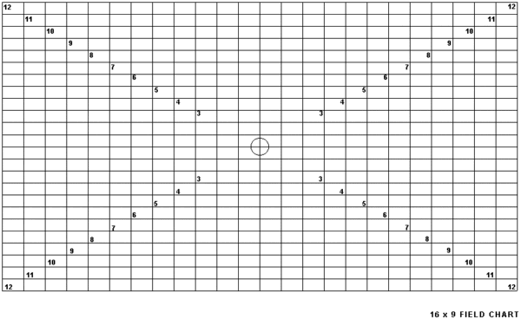

Animation Field Sizes and Field Guides.

When you draw a scene with your pencil on your light box, you trace each altered drawing from the previous one. Before you begin to draw, you need to establish your field size. Your field size is the area on the paper that you choose to draw within. If you simply use the full A4 paper size, you will encounter difficulties with the position of the peg bar. Also, it is a bad idea to work out to the edge of your paper, as the proportions of an A-4 sheet of paper do not reflect those of a T.V. screen.

A Standard 16X9 Field Chart.

Most good animation books will have a chart showing the field sizes, and there are several good websites where you can download one and print it off, for example,

http://www.animationpost.co.uk/novice_notes/field-sizes.htm

You need to be aware of the proportions of your images when setting up new projects, or exporting finished sequences.

There are a number of other tools and items of studio furniture that you will need to become familiar with if you are engaging in traditional 2D animation. Below is a list of the essential items.

A pegbar.

A pegbar is a standard piece of studio equipment used in professional animation studios. It is a small strip of plastic incorporating three plastic pins, two flat and one round. This little strip of plastic is vital when producing hand drawn animation, as it provides a registration system while drawing the animation and when recording the animation under the camera. If you wish to work in traditional 2D, you will need to buy your own peg bar. They are sold in the student union art shop, and cost £8. You can buy one at a cheaper price at this website. Make sure that you buy the three pin version, as this is the model that works with our studio punch. Make sure that you write your name on the back in permanent marker.

http://www.chromacolour.co.uk/store/animation_pegbars.php

A pencil
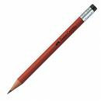
For Character based “cartoon” style animation you can work initially with a HB pencil, which is a good starter grade. It is important to note however that everybody has a different drawing style, and as you become more experienced with the animation process, you may wish to experiment with different grades. For more materials led techniques, chalk, ink or charcoal can be used. For experimental/abstract work anything that makes a mark can be animated.

A roll of masking tape

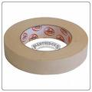

You will find that as you work on the animation lightbox, you may need to secure your peg bar on to the Perspex surface. You will need also to secure your peg bar to the table under the camera when line testing the animation. Masking tape is perfect, as it is easy to reposition, and it does not leave messy sticky patches. There may from time to time be a roll of tape left around the studios, but it is not an item supplied for your use, please invest in a roll and write your name on it.

An Animation field guide or “Graticule”

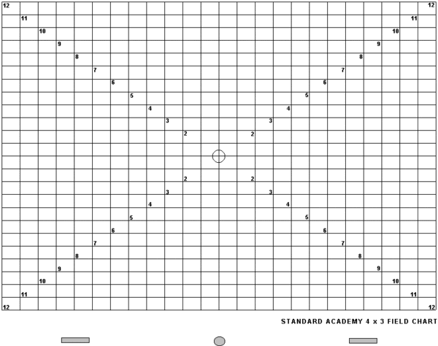

This is an A4 piece of paper printed with a grid. This grid represents a range of optional “frames” to use when drawing your images. These frames have been designed with the same aspect ratio as your capture device and playback screen, so there will be no distortion of your image in post production. Your field guide should be laminated, and pre punched for the peg bar.

A 12inch clear plastic ruler.

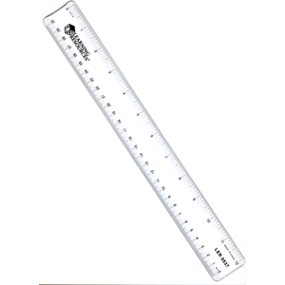

A stack of pre-punched photocopy paper

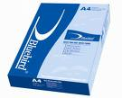

Special pre punched animation paper can be purchased online, but it is expensive. Any A4 photocopy or printer paper is perfect for the traditional animator. A punch will be provided for you in the illustration studios.

You will be provided with the following tools for the duration of the workshop, and left with your tutors for people to experiment with. These are not provided for independent use in any great numbers however,, so you will need to purchase your own equipment if you want to incorporate animation into your practice.

While on the course, you will also have access to the following specialist studio equipment…

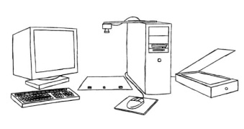

1) A line testing set up.
A line tester is any configuration of computer and camera equipment that can capture and play an image back at 25 frames per second. This could be as simple as a webcam, a couple of desk lamps and a laptop running a free downloadable piece of software…. Or it can be as complex as the capture set up in the illustration studios.

2) A studio punch

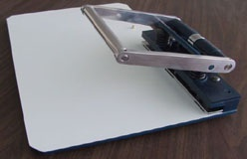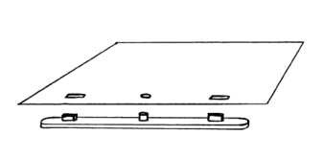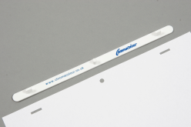

An animation studio punch is essentially a large version of a standard 2 hole paper punch. It is used to punch holes in A4 paper which correspond to the pins on the peg bar. It is essential for registering images, but it is horribly expensive (£800 to £1000) But there is a system which uses a 2 hole punch which is far more appropriate for a home studio.

3) An animation lightbox/disk

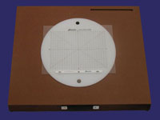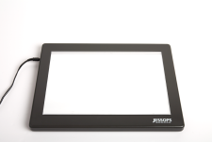

As your animation skills develop, the ability to work across several layers of paper becomes increasingly important. A light box is an important tool, and animators use a specially designed version.
These special lightboxes incorporate an adjustable height/angle, and contain a movable Perspex disk. This design is used in studios to minimise the risk of RSI (repetitive strain injury) often suffered by full time animators. In truth, any lightbox will do the job, and you need a professional model only if you plan to regularly animate for more than three or four a day over four or five days. For the beginner, a small portable light box, a glass topped table, or even a bright window will suffice. Two professional lightboxes have been left with the illustration tutors for your use.

Using your Field Guide, peg bar and light box.

The following images show a small portable lightbox, and a 2 pin peg bar. The process is exactly the same when using a three pin peg bar and a professional animator’s light box.

- Attach your peg bar to the surface of your light box
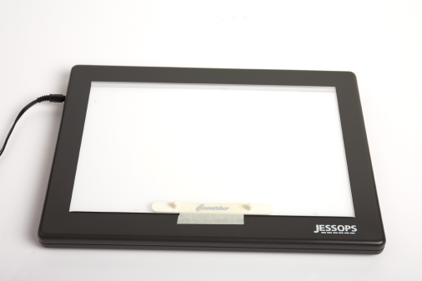

- Place your punched field guide on to the pegs, and place a blank sheet of paper on top.

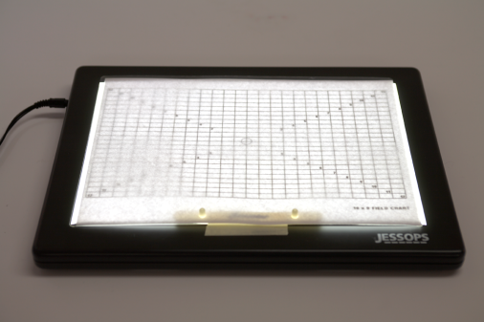

- Select a field size, (Most animators work somewhere between 4 and 8) Using your pencil and ruler, clearly trace out the selected size on to your blank sheet of paper.

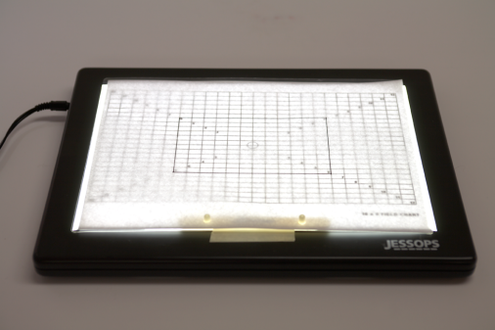

- Take both the sheet with the selected size drawn on it, and the field guide grid off the bar, and put the field guide grid away. Place the newly selected filed size back on the bar, and write the number in the bottom right hand corner. Here, we have chosen field size 6, so the words “field size 6” should be clearly written in the bottom right hand corner.

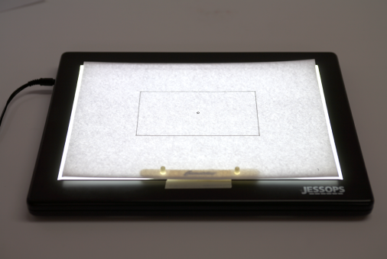

- This field size frame now remains on the pegbar throughout the entire sequence. Every subsequent frame is drawn on a new sheet of paper, which is placed on top of this guide.

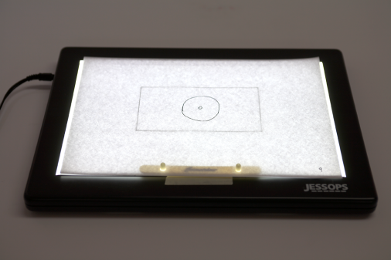

- As each new frame is completed, it should be clearly numbered in the bottom right hand corner of the page.

- When you are shooting your sequence on the line tester, use the field guide to assist you in framing under the camera.

