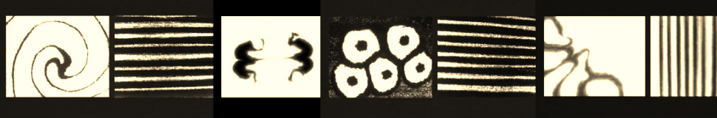

Animation Foundations
Induction Training Hub 1 – Stop Motion and Under Camera techniques.
Assignment 1 – Producing an audio driven abstract sequence.

Brief
The study and analysis of movement is critical to your studies as a student of animation. In this session we will focus on the following four key concepts when considering basic movement in abstract animation.

Rhythm Speed control pattern

Following a seminar and discussion, you will get into pairs and plan and produce a five-second sand on glass sequence. This experimental/abstract sequence should be traditional and destructive in its nature, and must be produced in response to a pre-recorded audio track.

Session Aims
- The training delivered in this session builds on the practical training and skills introduced in the morning session, and you will have the opportunity to apply this learning as you set up and use the capture booths and stop motion stations to shoot a longer and more ambitious sequence.
- The exercise will also allow you to investigate how timing and movement can be exploited to create meaning and to explore the use of audio as a source of inspiration in narrative development.

Technical Learning Objectives - When you come to work independently in the stop motion studios this session will help you to | learning outcomes – When you are assessed the work produced during this session will provide you with evidence towards:
- Be more confident in the key "Terms and Conditions" in setting up and using a DSLR camera and capture station to shoot sand on glass, and other traditional 2D techniques.  - Have first-hand experience of the key constraints of under camera work (Light control, registration, camera “throw” and field size.)  Observe and apply the Health and Safety considerations necessary to ensure a safe and sustainable working environment. | - The use and application of a range of animation and filmmaking techniques in relation to practical work.  - Your understanding of the principles of animation in assignments.  - Your ability to observe, analyse, compare and contextualise animated dynamics and performance;

